TeamAdmin 2023

Documentation – APR400 – Database Lab

Marco Teran Gutmanowitz

# Grade aimed for

A (I have fulfilled all criterias as far as I know)

Note: this is a general documentation about the app. I have not delved into details about how the code is structured and so on here, because the specification for the documentation was just that it is supposed to be brief with images of the program running.

# App description

This is an administrative application for managers of soccer. This application allows you to gain an oversight over your different teams, players, trainers of said teams and any competitions that are coming up in the world.

# App structure

**Database**: SQLite database. This database is used for storing and displaying the different teams and players in the application. There is a Many-to-many relationship between these two tables. There is thus a junction table that is called TeamPlayerHistory, which is utilized to show the history of a player. I.e the different teams the player has played for in the past.

**MongoDB connection**: Trainers. The MongoDB connection is used for the display of the different trainers in the application. There is also a possibility to add a new trainer. The MongoDB database consists of trainers and teams. Note that, due to time constraints, the teams for the trainers are not related to the teams of the players.

**API connection**: Competitions. An API is used to retrieve a list of soccer competitions in the order of latest start date.

**UI Elements:** The following UI elements/libraries/etc are used in order to give the UI a better feel:

* Font Awesome – for icons in the application and also responsible for the rotating animation of the football (actually a volleyball) logo in the top left hand corner of the screen.

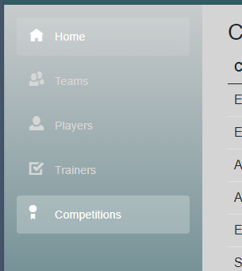

* Modal – to give “floating windows” for the different action pages in the application, such as Edit, Delete etc.

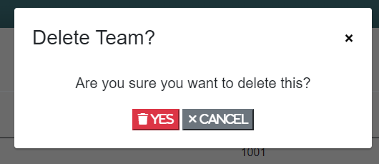

# App pages

* Home
  + This is the entry point/home page for the application. When you enter the page, you will be greeted with a welcome message, today’s date and an overview of the players, teams and trainers you are managing. Note that you need to be connected to the VPN for the home page to load quickly, otherwise it will take about 10 seconds for it to display.

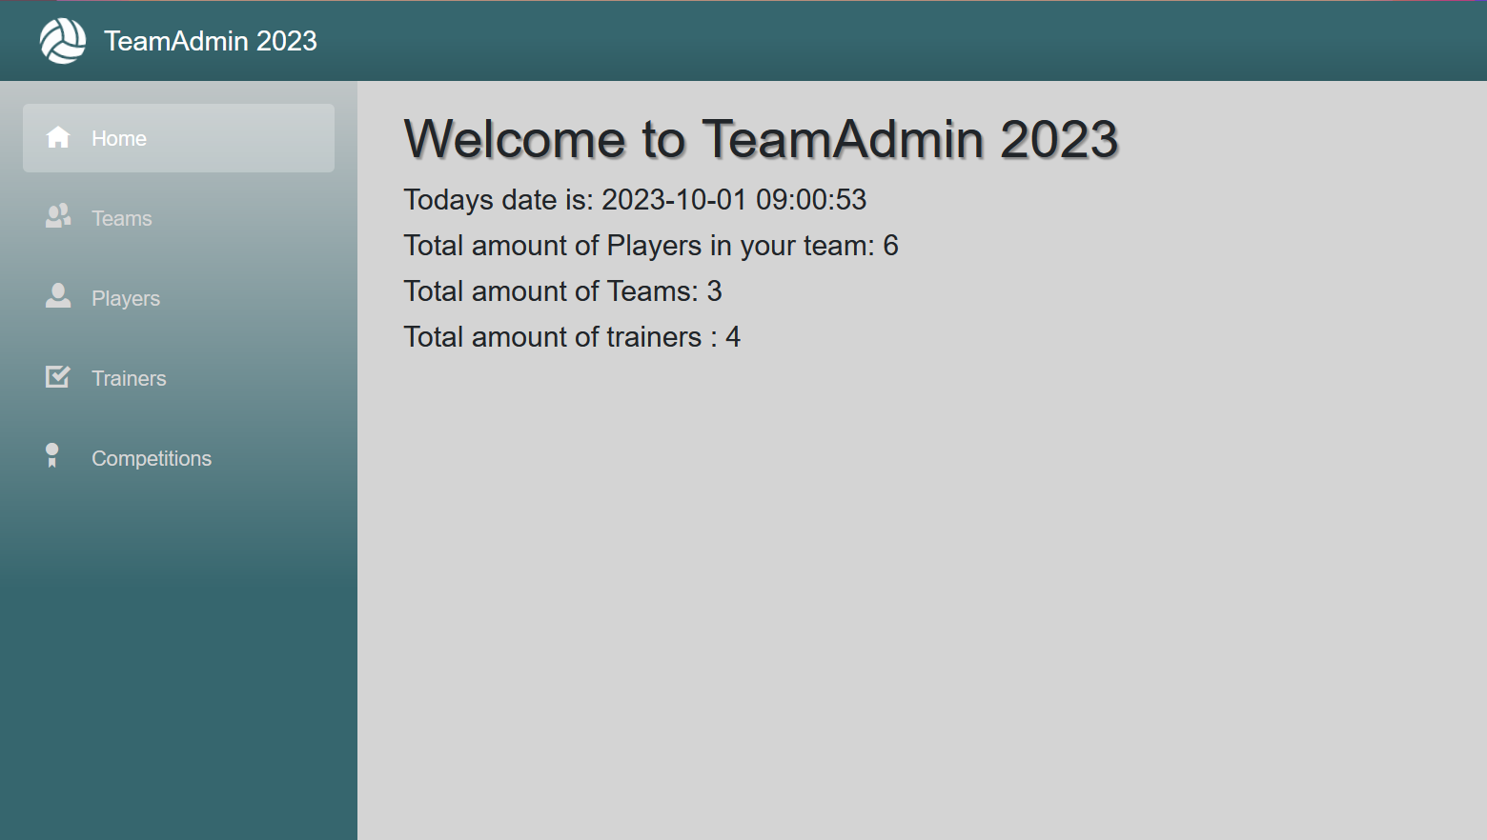

* Teams
  + Here the different teams are shown in a data table. Different information, such as Team name, home stadium, and the amount of won championship are possible to see here. You can also edit a team or delete it (CRUD).

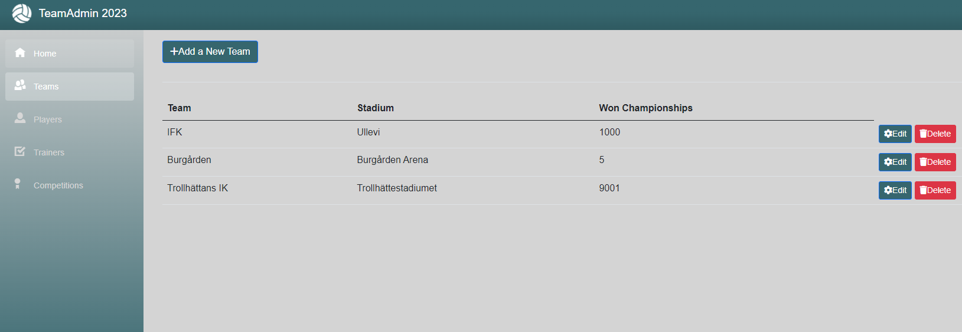

* Players
  + Here we can see the different players that we are administrating, in a structured way. Each player is listed in a table for each team. It is possible to edit a player, delete the player and see the players team history (which teams the player has belonged to in the past).

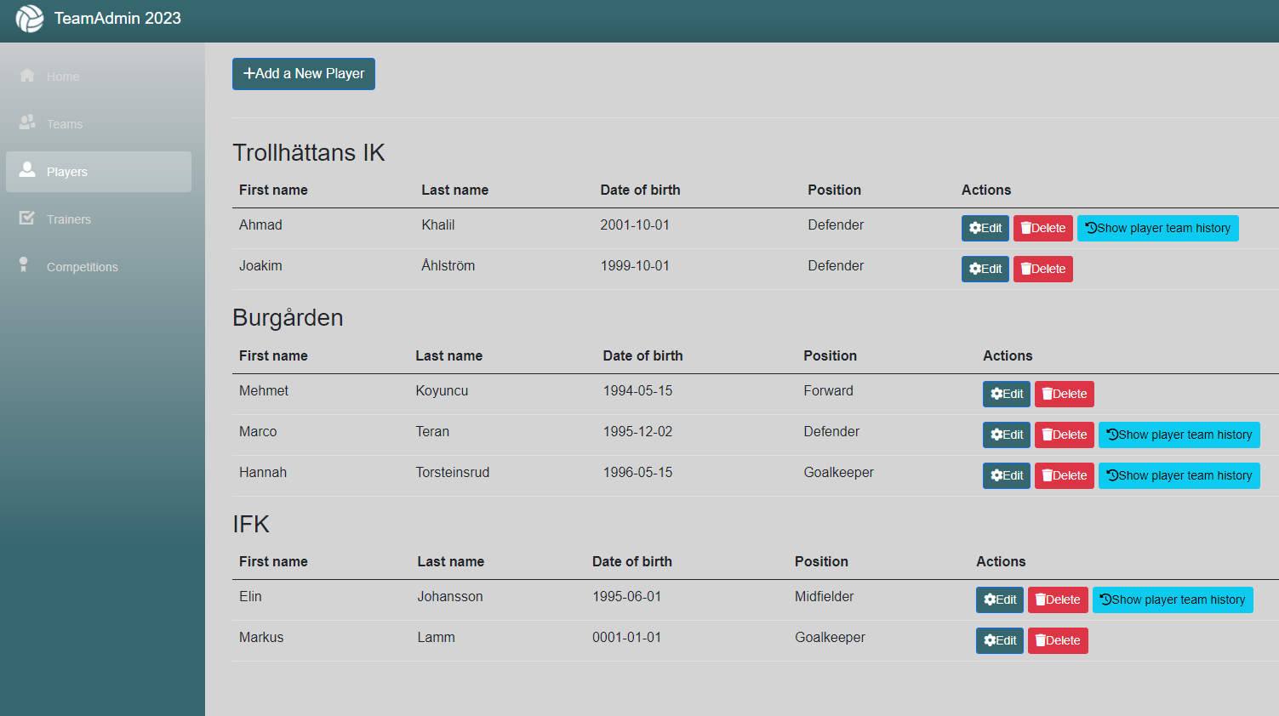

* Trainers
  + This page utilized the MongoDB connection to retrieve the trainers that are in the MongoDB database. It is also possible as per the criteria to add a new trainer from the application. This page also requires you to be connected to the VPN.

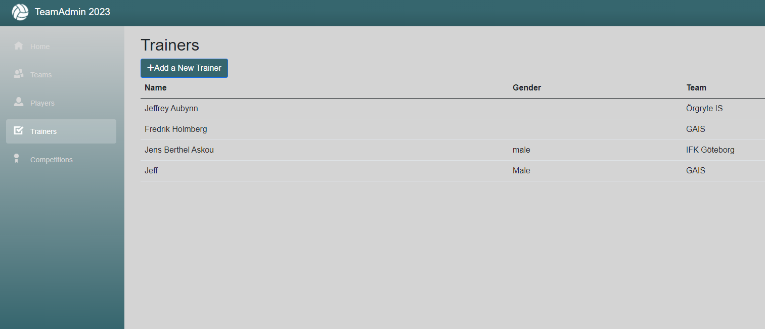

* Competitions
  + This page utilizes a soccer cup Api that returns upcoming and past competitions. The competitions are organized by the latest start date, so that upcoming competitions are shown at the top.

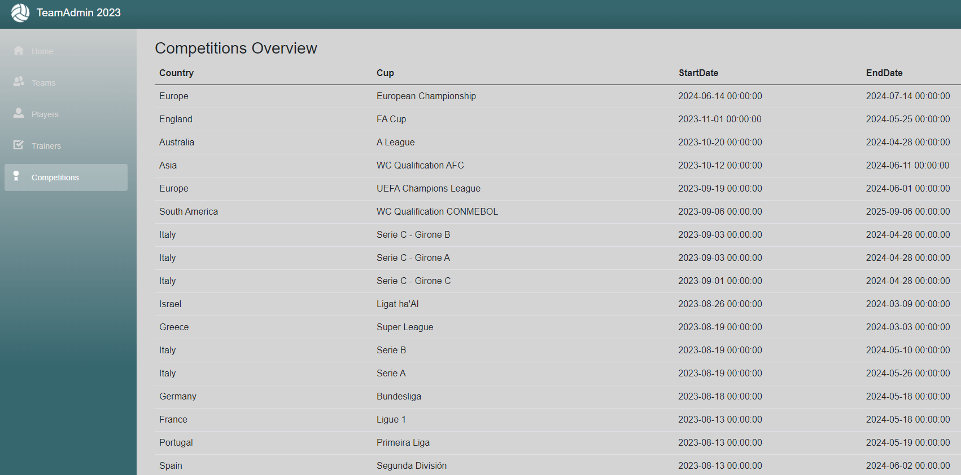

# SQL-script

